**DEPARTMENT OF INFORMATION TECHNOLOGY**

**Course Name and Code:** Data Structures Lab **(**ITL302)

**Semester:** III (SYIT)

**Academic Year:** 2024-25 (Odd Semester)

**Experiment No. 02**

**Aim:** Implementation of Queue using an array for real-world application.

**Objectives:**

1. To introduce the concepts of data structures and analysis procedure.
2. To conceptualize linear data structures and its implementation for various real-world applications.

**Code :-**

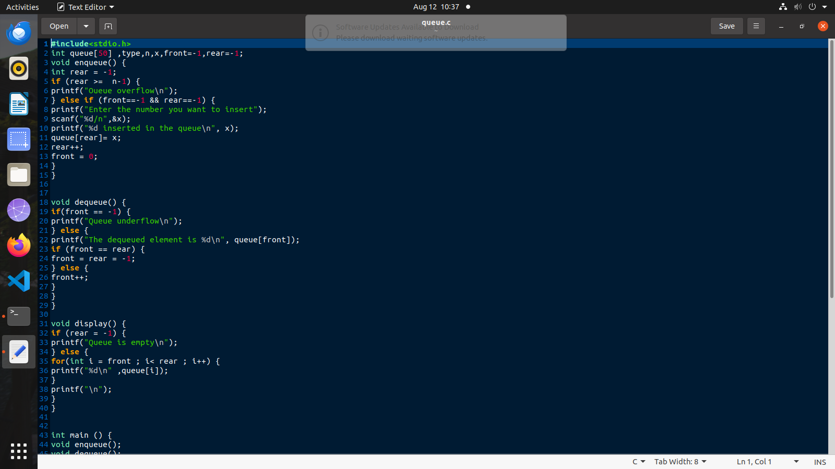

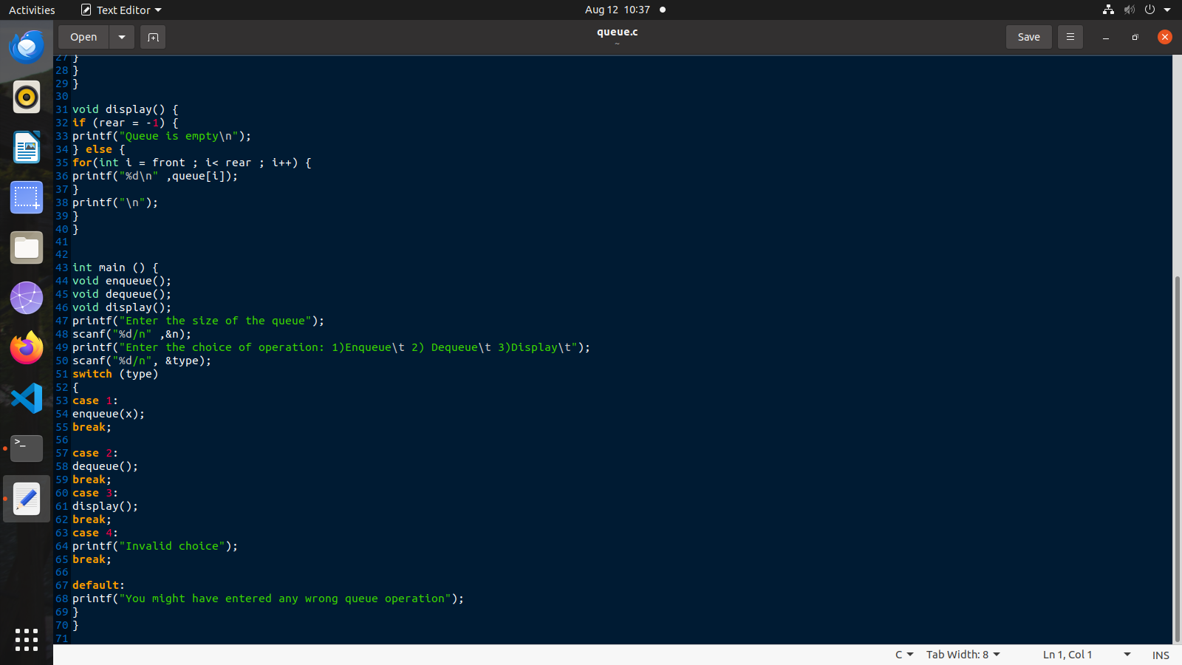

**Output :-**

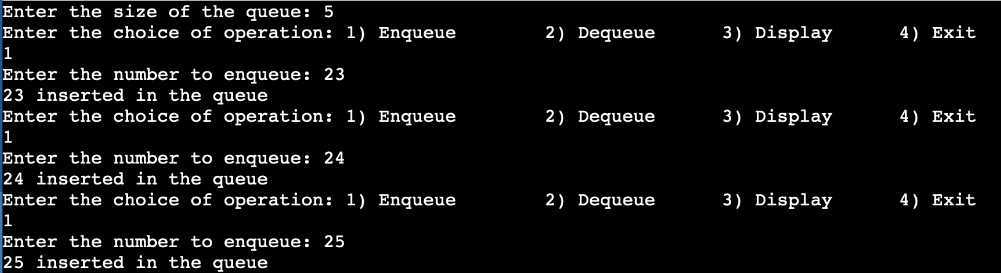

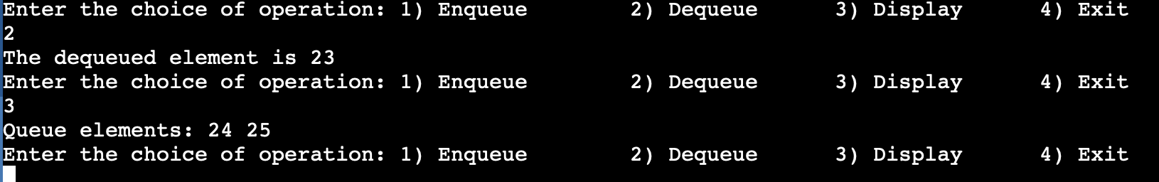

**Submitter Details:-**

**Name :- Veer Gokani**

**Roll no :- 30**

**Date of Submission :- 13/08/24**

**Div / Batch :- A - S2**

.

**Submitted Details -**

**Name of Student: Veer Gokani**

**Roll No.: 30**

**Date of Performance: 05/08/2024**

**Date of Submission: 07/08/2024**